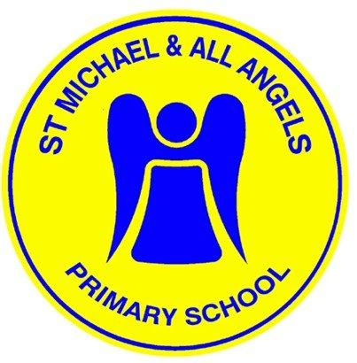
St Michael and All Angels
Pupil Admissions Committee
Terms of Reference
2023-24
As members of the Governing Body of SMAAA we pledge to:
Follow the 7 Principles of Public Life outlined by Lord Nash including:
- selflessness;
- integrity;
- objectivity;
- accountability;
- openness;
- honesty;
- leadership.
We will also:
Area | Responsibilities
Organisation and teamwork | - review the terms of reference for this committee;  - set out a monitoring plan annually;  - participate in training;  - agree to use the Nolan principles of public office;  - review / make recommendations for policies with key staff.
Recruitment and retention/ communicate with parents/carers | - contribute to the School Development Plan;  - contribute to the schools Self-evaluation;  - actively engage with the School Council and other groups of pupils;  - engage with parents through questionnaires and surveys.
Strategic Leadership and Statutory Responsibilities | - be responsible for the leadership of specific activities;  - monitor the Performance Management process.
Strengths and Weaknesses/Self-Review and Change | - read and evaluate case studies from key staff;  - contribute and participate in key chosen areas of development;  - attend school events;  - follow up on proposed actions.
Support and Challenge | - work with staff and other Governors;  - promote the good reputation of the school;  - ask questions and ensure that challenges are followed through;  - engage with the school leadership team.
Impact/including school improvement/pupil safety and well being/partnerships and community engagement | - we will identify a priority that will improve outcomes for pupils;  - we will decide what to do;  - we will review what action the school took;  - we will review the impact;  - we will review the lessons that we learned.

Membership and Meetings
Membership and Meetings
- there will be a minimum of three Governors plus the Headteacher;
- this Committee will meet on an annual basis, and
- this Committee will be Chaired by Rev Andrew Rowlands during the academic year 2023-24 .
Quorum
Three members of the committee including the Headteacher or his/her representative.
Terms of reference
We will
Area | Responsibilities
  - Determine offers of places for the annual admissions round in the light of the governors' admissions policy and within the timescales and procedures of the Authority’s co-ordinated scheme;
  - Determine offers of places to ‘mid-term’ applicants in the light of the governors' admissions policy and requirements of the Authority’s co-ordinated scheme;
  - Review the Governing Body’s admissions policies annually and make any recommendations for change to the whole Governing Body;
  - Ensure publication of the school’s Admissions Arrangements in the School Prospectus and/or on-line as required by regulation and Codes of Practice;
- Ensure that the consultation process is carried out in accordance with guidance contained in the School Admissions Code of Practice;
- Ensure that admission appeals are held according to timescales in the Code of Practice and that appropriate case papers are produced as required.

